NAME: DISHANT ARORA
REG. NO.: 180905462
PP LAB
WEEK 1

Q1. (mpi program to print pow(x,rank) where x is constant and rank is the rank of the process)
#include "mpi.h"
#include <stdio.h>
#include <math.h>

int main(int argc, char *argv[]){
int rank;
int x = 2;
MPI_Init(&argc,&argv);
MPI_Comm_rank(MPI_COMM_WORLD,&rank);
// MPI_Comm_size(MPI_COMM_WORLD,&SIZE);
printf("pow(x,rank) = %f\n",pow(x,rank));
MPI_Finalize();
return 0;
}

OUTPUT:
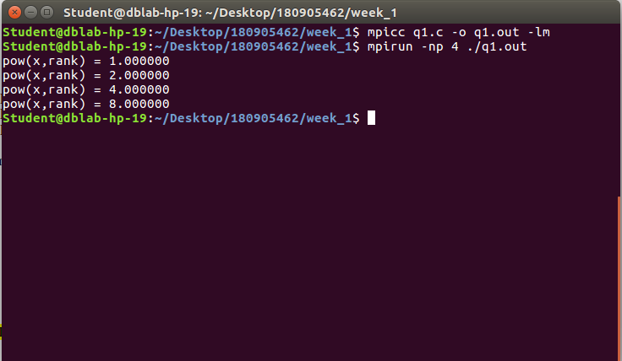

Q2. (mpi program that prints “hello” is the process has an even rank and “world” if the process has an odd rank)
#include "mpi.h"
#include <stdio.h>
#include <math.h>

int main(int argc, char *argv[]){
int rank;
MPI_Init(&argc,&argv);
MPI_Comm_rank(MPI_COMM_WORLD,&rank);
if(rank%2==0){
printf("Hello\n");
}
else{
printf("World\n");
}
MPI_Finalize();
return 0;
}

OUTPUT:
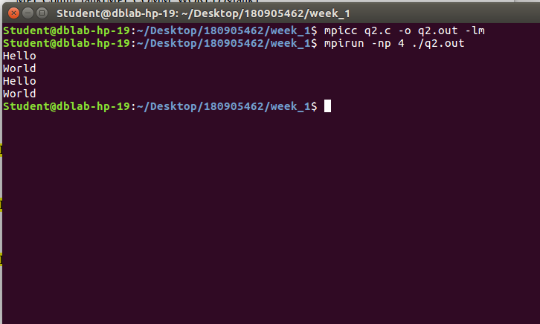

Q3. (mpi program to simulate a calculator with each operation performed by a different process)
#include "mpi.h"
#include <stdio.h>
#include <math.h>

int main(int argc, char *argv[]){
int rank;
int a = 7, b=3;
MPI_Init(&argc,&argv);
MPI_Comm_rank(MPI_COMM_WORLD,&rank);
//calculator functions
if(rank == 0){
printf("multiplication: %d\n",a*b);
}
else if(rank == 1){
printf("addition: %d\n",a+b);
}
else if(rank == 2){
printf("division: %d\n",a/b);
}
else{
printf("subtraction: %d\n",a-b);
}
MPI_Finalize();
return 0;
}

OUTPUT:
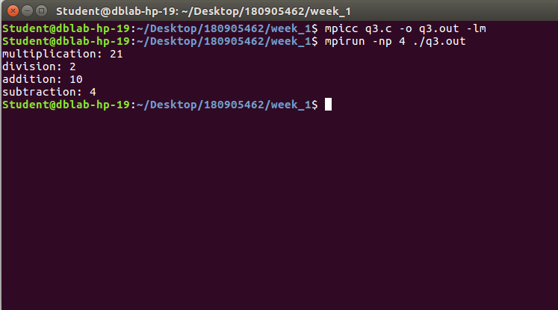

Q4. (mpi program to toggle the characters of a string)
#include "mpi.h"
#include <stdio.h>
#include <math.h>

int main(int argc, char *argv[]){
int rank;
char str[] = "HeLLo";
// printf("initial string: %s\n",str);

MPI_Init(&argc,&argv);
MPI_Comm_rank(MPI_COMM_WORLD,&rank);
if(rank == 0){
if(str[0] >= 'a' && str[0] <= 'z'){
printf("%c",str[0]-32);
}
else{
printf("%c",str[0]+32);
}
}
else if(rank == 1){
if(str[1] >= 'a' && str[1] <= 'z'){
printf("%c",str[1]-32);
}
else{
printf("%c",str[1]+32);
}
}
else if(rank == 2){
if(str[2] >= 'a' && str[2] <= 'z'){
printf("%c",str[2]-32);
}
else{
printf("%c",str[2]+32);
}
}
else if(rank == 3){
if(str[3] >= 'a' && str[3] <= 'z'){
printf("%c",str[3]-32);
}
else{
printf("%c",str[3]+32);
}
}
else{
if(str[4] >= 'a' && str[4] <= 'z'){
printf("%c",str[4]-32);
}
else{
printf("%c",str[4]+32);
}
}
MPI_Finalize();
return 0;
}

OUTPUT:
